Hypervisor - a software that can run multiple vm

Bare metal hypervisor

Code
- Tree ____/ - just like ls but it copies all of it including the subdirectories
- Sudo openvpn user.ovpn - this code is vulnerable to others and if it tells that initiation complete means that is successfully connected to the vpn
- Ifconfig - lets you see if another window is successfully in and it should be in Tun
- Netstat -rn - lets you show the network accessible on the vpn
- Nmap - lets you scan the target , sC - specify the scan, sV - instructs nmap to a version scan, -p- - tells nmap to scan all tcp ports
- Nmap script <script name> -p<port> <host> - Specifying -sC will run many useful default scripts against a target, but there are cases when running a specific script is required
- Ftp- it's a way to transfer files between two computers over a network. And you can use code for it just like in terminal like cd,ls,get,put,exit.

Basic tools
- SSH - runs on port 22 SSH can be configured with password authentication or passwordless using public-key authentication using an SSH public/private key pair. SSH can be used to remotely access systems on the same network, over the internet, facilitate connections to resources in other networks using port forwarding/proxying, and upload/download files to and from remote systems.
Example code:
ssh Bob@10.10.10.10
Bob@remotehost's password: *********

- Netcat - Netcat, ncat, or nc, is an excellent network utility for interacting with TCP/UDP ports. It can be used for many things during a pentest. Its primary usage is for connecting to shells, which we'll discuss later in this module. In addition to that, netcat can be used to connect to any listening port and interact with the service running on that port. For example, SSH is programmed to handle connections over port 22 to send all data and keys. We can connect to TCP port 22 with netcat:
- Example code:
- pab042004@htb[/htb]$ netcat 10.10.10.10 22
- SSH-2.0-OpenSSH_8.4p1 Debian-3

- Tmux - can run a multiple terminal but you can sudo apt update and upgrade it

- Vim - a text editor
- 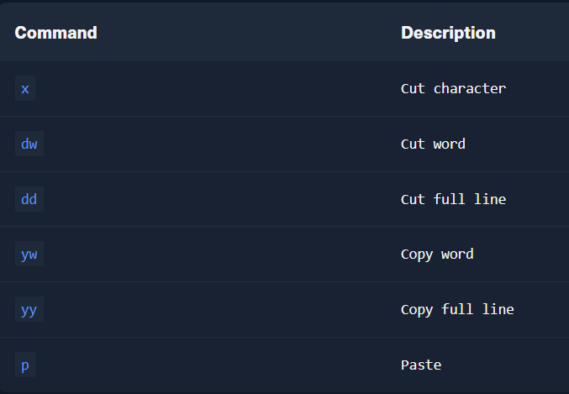
- 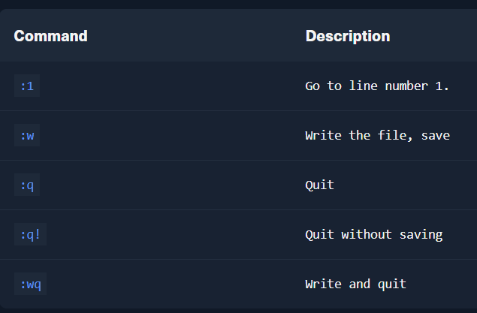

Banner Grabbing - a technique that can quickly get a service

SMB - SMB (Server Message Block) is a prevalent protocol on Windows machines that provides many vectors for vertical and lateral movement. Sensitive data, including credentials, can be in network file shares, and some SMB versions may be vulnerable to RCE exploits such as EternalBlue. It is crucial to enumerate this sizeable potential attack surface carefully. Nmap has many scripts for enumerating SMB, such as smb-os-discovery.nse, which will interact with the SMB service to extract the reported operating system version.
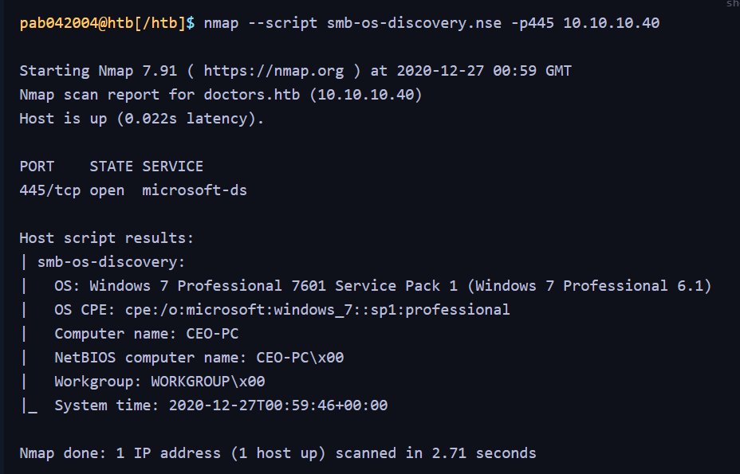
The -L flag specifies that we want to retrieve a list of available shares on the remote host, while -N suppresses the password prompt.
